Lab 1 Classes and Objects

Exercise 1
Question: Create a Car class with brand, year and mileage, display three cars.
Java source code:
class Car {
String brand;
int year;
double mileage;

void display() {
System.out.println(brand + " " + year + " mileage: " + mileage);
}
}

public class Exercise1Cars {
public static void main(String[] args) {

Car car1 = new Car();
car1.brand = "Toyota";
car1.year = 2018;
car1.mileage = 65000;

Car car2 = new Car();
car2.brand = "Honda";
car2.year = 2020;
car2.mileage = 42000;

Car car3 = new Car();
car3.brand = "Mazda";
car3.year = 2015;
car3.mileage = 88000;

// Display each car using its own details.

car1.display();
car2.display();
car3.display();

}
}

Expected output (sample):
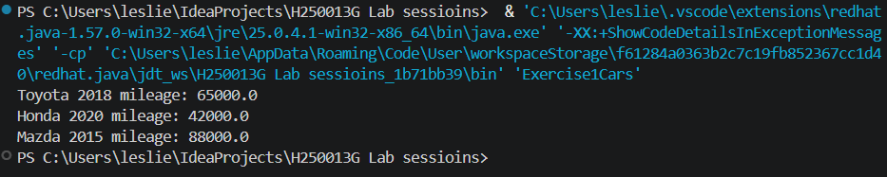

Explanation: A Car object stores its own brand, year and mileage. The loop calls display() for all three objects.

Exercise 2
Question: Add isAntique(), true when a car is more than 25 years old.
Java source code:
import java.time.Year;

class AntiqueCar {
String brand;
int year;

boolean isAntique() {
// The age check uses the current calendar year.
return Year.now().getValue() - year > 25;
}
}

public class Exercise2AntiqueCar {
public static void main(String[] args) {
AntiqueCar car = new AntiqueCar();
car.brand = "Toyota";
car.year = 1998;
System.out.println(car.brand + " antique? " + car.isAntique());
}
}

Expected output (sample):
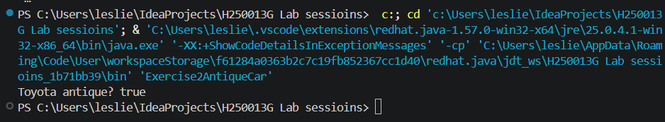

Exercise 3
Question: Create Rectangle with area and perimeter; print the largest area from an array of five.
Java source code:
class MeasuredRectangle {
double width;
double height;

MeasuredRectangle(double width, double height) {
this.width = width;
this.height = height;
}

double area() {
return width * height;
}

double perimeter() {
return 2 * (width + height);
}
}

public class Exercise3LargestRectangle {
public static void main(String[] args) {
MeasuredRectangle[] rectangles = {
new MeasuredRectangle(2, 3),
new MeasuredRectangle(4, 5),
new MeasuredRectangle(3, 6),
new MeasuredRectangle(7, 2),
new MeasuredRectangle(5, 5)
};
MeasuredRectangle largest = rectangles[0];
// Keep the largest area found so far.
for (MeasuredRectangle rectangle : rectangles) {
if (rectangle.area() > largest.area()) {
largest = rectangle;
}
}

System.out.println("Largest area: " + largest.area());
System.out.println("Perimeter: " + largest.perimeter());
}
}

Expected output (sample):
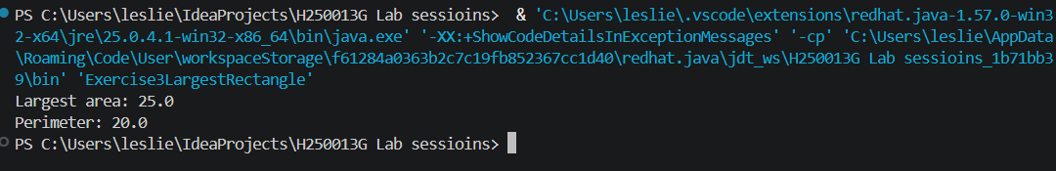
Explanation: area() multiplies width by height; the loop keeps the rectangle with the greatest area.

Exercise 4
Question: Assign Rectangle r2 = r1, change r2.width, and print r1.width.
Java source code:
class ReferencedRectangle {
double width;

ReferencedRectangle(double width) {
this.width = width;
}
}

public class Exercise4RectangleReference {
public static void main(String[] args) {
ReferencedRectangle r1 = new ReferencedRectangle(5);
// Both variables point to this same rectangle.
ReferencedRectangle r2 = r1;
r2.width = 12;
System.out.println("r1.width = " + r1.width);
}
}

Expected output (sample):
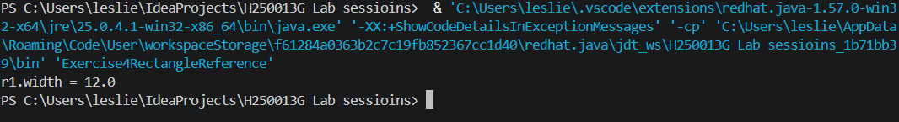Explanation: r2 = r1 copies the reference, not the object. Therefore changing the object through r2 is visible through r1.

Exercise 5
Question: Create Address and Person; print city using a chained dot expression and show null handling.
Java source code:
class Address {
String city;

Address(String city) {
this.city = city;
}
}

class AddressPerson {
String name;
Address address;

AddressPerson(String name, Address address) {
this.name = name;
this.address = address;
}
}

public class Exercise5PersonAddress {
public static void main(String[] args) {
AddressPerson person = new AddressPerson("Leslie Sarai", new Address("Harare"));
System.out.println(person.name + " lives in " + person.address.city);

AddressPerson other = new AddressPerson("Tariro", null);
// An address can be absent, so check before using it.
if (other.address == null) {
System.out.println("Address is not available");
}
}
}

Expected output (sample):
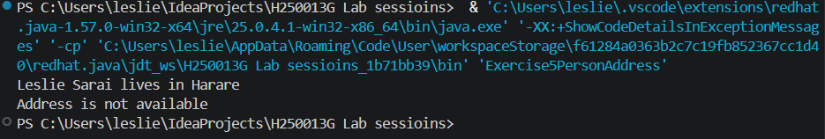

Explanation: The chained expression reaches city through person.address. Check for null before accessing a nested object to avoid NullPointerException.

